# Rain Water Harvesting

# 

| **Supervisor** | SIR Muhammad Haris | |
| --- | --- | --- |
| **Batch** | 2401F2 | |
| **Group** | **D** | |
| **Serial No.** | **Enrollment Number** | **Student Name** |
| 1. | Student1546283 | Zubair Ahmed |
| 2. | Student1546969 | Mamoon Sher |
| 3. | Student1546938 | Yasir Khan |
| 4. | Student1522826 | Alwaz Kashif |

# Problem Statement:

Despite the increasing awareness of water scarcity and the potential benefits of rainwater harvesting, many regions around the world still face significant challenges in implementing and optimizing rainwater harvesting systems. The primary issues include:

1. **Inconsistent Rainfall Patterns**: Variability in rainfall, with some areas experiencing prolonged dry periods, limits the reliability and effectiveness of rainwater harvesting.
2. **Initial Setup Costs**: The cost of installing rainwater harvesting systems, including catchment areas, storage tanks, and filtration units, can be prohibitive for many households and communities.
3. **Maintenance and Quality Control**: Ensuring the quality of harvested rainwater requires regular maintenance and monitoring of the system to prevent contamination and ensure the water remains safe for use.
4. **Public Awareness and Education**: A lack of understanding and awareness about the benefits and methods of rainwater harvesting can hinder its adoption. Educating the public on how to effectively implement and maintain these systems is crucial.
5. **Regulatory Barriers**: In some regions, legal and regulatory frameworks either do not support or actively restrict the practice of rainwater harvesting, creating obstacles for widespread adoption.
6. **Urban Infrastructure**: In densely populated urban areas, limited space and existing infrastructure can pose significant challenges to the installation of effective rainwater harvesting systems.

**Hardware/ Software Requirements**

**Hardware**

**• A minimum computer system that will help you access all the tools in the**

**courses is a Pentium 166 or better**

**• 64 Megabytes of RAM or better**

**Software [Either or Combination as per Course/Sem]**

**• Notepad/HTML editor/CoffeeCup**

**• Angular / Angular JS / React / BootStrap**

**• Dreamweaver / Figma**

**• MS IE / Chrome / FireFox / Netscape /MS Edge**

**Acknowledgement:**

**We are delighted to undertake the development of a cutting-edge responsive website for Oxford Sofas, the world's leading online marketplace for fine art, antiques, furniture, and collectibles. Our team's expertise in HTML5, JSON, JavaScript, and Geolocation, combined with a commitment to cross-browser compatibility, ensures that we will deliver a user-friendly platform that not only simplifies the process of discovering and acquiring coveted items but also streamlines online auctions, eliminating the need for extensive paperwork. We are eager to work with Oxford Sofas to bring this vision to life and provide collectors worldwide with a modern, efficient, and profitable auctioning experience.**

**Synopsis:**

Rainwater harvesting is an ancient yet increasingly relevant practice that involves the collection and storage of rainwater for various uses. With growing concerns over water scarcity, climate change, and sustainable resource management, rainwater harvesting presents a viable solution to augment water supply and reduce dependency on traditional water sources.

1. **Catchment Area**: Typically rooftops, where rainwater is initially collected.
2. **Conveyance System**: Gutters and downspouts that channel the water from the catchment area to the storage tanks.
3. **First Flush Diverters**: Devices that discard the initial runoff, which may contain contaminants.
4. **Filtration Systems**: Filters that remove debris and impurities from the collected water.
5. **Storage Tanks**: Containers, often above or below ground, where the water is stored.
6. **Distribution System**: Pipes and pumps that deliver the stored water for various uses.:

**Introduction:** In response to the growing demand for a user-friendly and efficient online marketplace for Sofas, furniture, and collectibles, this project aims to develop a responsive website for Oxford Sofas. As the world's leading platform in its category, Oxford Sofa seeks to enhance the experience for collectors worldwide by simplifying the acquisition process and streamlining online auctions.

**User Interface:** The heart of this project lies in creating an intuitive and engaging user interface. Leveraging HTML5, JSON, JavaScript, and Geolocation, our team will design a dynamic and visually appealing website that offers real-time pricing and ensures a seamless experience across various browsers, including Chrome, IE, Firefox, and more

**Conclusion:** In conclusion, this project represents a transformative step forward for Oxford Sofas. By leveraging cutting-edge technology and a user-centric approach to website development, we aim to maximize profitability for our client and provide collectors worldwide with a modern, efficient, and convenient platform for acquiring their cherished items. This endeavor signifies our commitment to excellence, and we look forward to delivering a website that not only meets but exceeds the expectations of Oxford Sofas and its valued users.

**Sitemap:**

**HOME**



















**Carousel:**

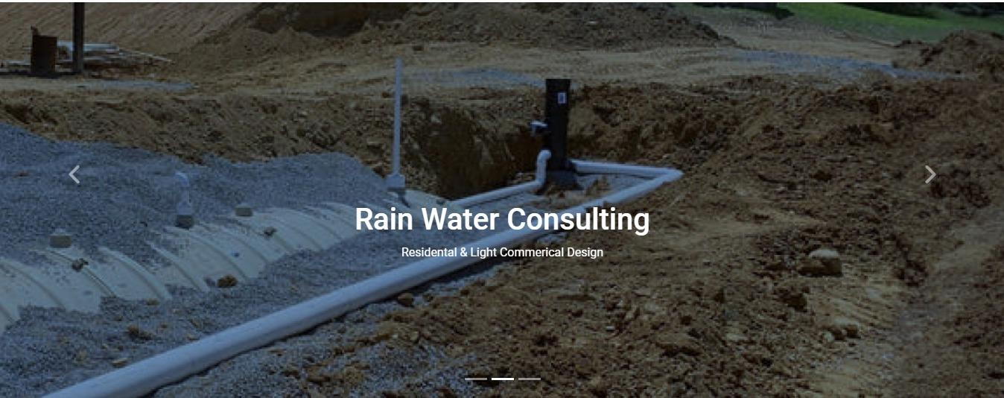

**Navbar:**



* There are seven essentials listed here, and you will be redirected to all the pages, which are further classified as:
* Home
* RESIDENTIAL HARVESTING
* COMERCIAL HARVESTING
* FOOTER
* ABOUT US
* CONTACT

**About Us:**

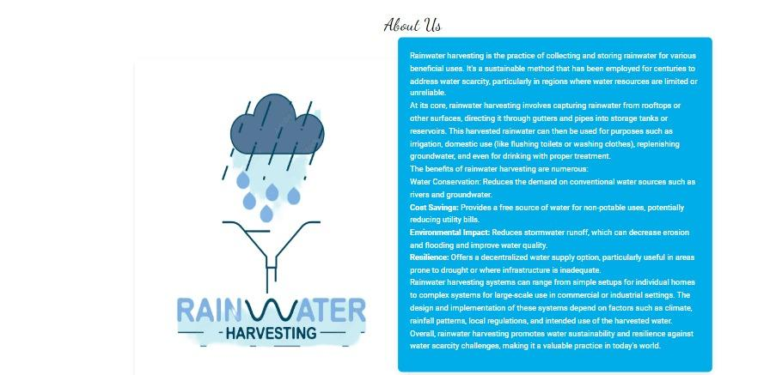

**Contact Us:**

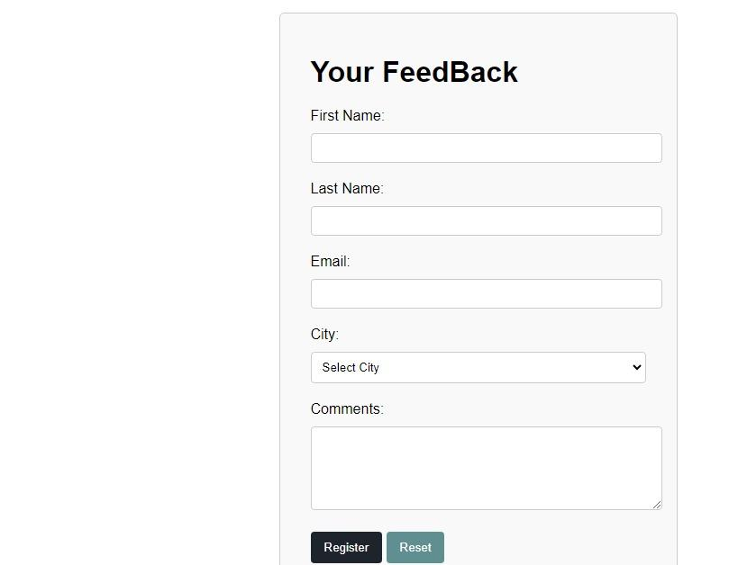

**Footer:**

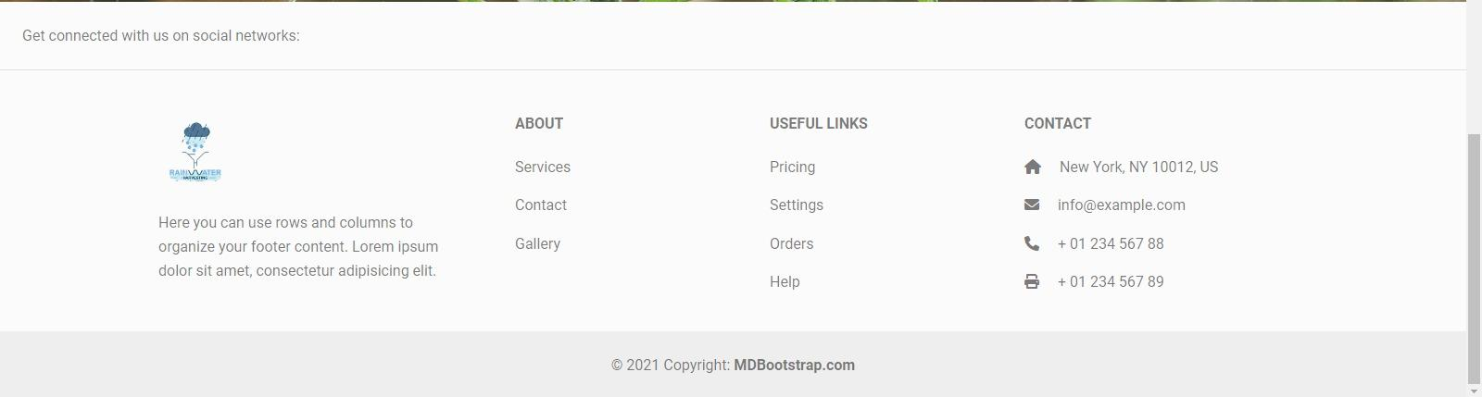

**Task Sheet Review:**

|  | | **Project Title** | **Date of Preparation of Activity Plan** | | | |
| --- | --- | --- | --- | --- | --- | --- |
| No. | **Task** | **Rain Water**  **Harvesting** | Actual | Actual | Name | Status |
| Start date | Days |
| 1 | Navbar & Footer |  | 5/6/24 | 2 | Zubair Ahmed | Complete |
| 2 | Build Home Page |  | 7/6/24 | 3 | zubair and MAmoon | Complete |
| 3 | Build residential Page |  | 11/6/24 - | 4  - | zubair ahmed  - | Complete |
| 4 | Build About Us Page |  | 15/6/24 | 3  1to10 | mamoon | Complete |
| 5 | Build Contact Us |  | 25/6/24 | 4 | mamoon | Complete |
| 6 | Build product Page |  | 29/6/24 | 2 | mamoon | Complete |
| 7 | commercial harvesting |  | 2/7/24 | 2 | Yasir | Complete |
| 8 | make over website documentation |  | 4/7/24 | 1 | yasir | Complete |
| 9 | residential harvesting |  | 7/7/24 | 5to6 | Zubaur Ahmed | Complete |
| 10 | aBout us and contact Us |  | 9/7/24 | 4 | mamoon | Complete |
|  |  |  |  |  |  |  |
|  |  |  |  |  |  |  |
|  |  |  |  |  |  |  |
|  |  |  |  |  |  |  |
|  |  |  |  |  |  |  |
|  |  |  |  |  |  |  |

**Summary:**

Rainwater harvesting is the practice of collecting and storing rainwater for future use, which offers numerous environmental, economic, and social benefits. The process typically involves capturing rainwater from rooftops or other surfaces, channeling it through gutters and downspouts, filtering out debris and contaminants, and storing it in tanks for later use.

* **Catchment Area**: Usually rooftops where rainwater is collected.
* **Gutters and Downspouts**: Direct the water from the catchment area to storage.
* **First Flush Diverters**: Remove initial contaminants from the runoff.
* **Filters**: Clean the water before storage.
* **Storage Tanks**: Hold the collected water, available in various sizes and materials.
* **Distribution System**: Delivers stored water for different uses.
* **Water Conservation**: Reduces dependence on municipal water supplies and groundwater.
* **Cost Savings**: Lowers water bills by providing a free source of water.
* **Flood Mitigation**: Reduces runoff, helping to prevent urban flooding.
* **Environmental Protection**: Minimizes soil erosion and decreases the strain on stormwater infrastructure.
* **Irrigation**: Watering gardens, lawns, and agricultural fields.
* **Household**: Flushing toilets, washing clothes, and general cleaning.
* **Industrial**: Cooling, cleaning, and fire suppression.
* **Potable Water**: After proper treatment, can be used for drinking and cooking.
* **Inconsistent Rainfall**: Variability can limit the reliability of harvested rainwater.
* **Initial Costs**: The setup can be expensive, though it pays off over time.
* **Maintenance**: Regular upkeep is necessary to ensure water quality.